Table of Contents for Specific Requirements Document

2. Specific Requirements 15
2.1. Introduction 15
2.1.1. Purpose 15
2.1.2. Scope 15
2.1.3. Definitions, Acronyms, and Abbreviations 15
2.1.3.1. Definitions 15
2.1.4. References 16
2.1.5. External Interface Requirements 16
2.1.5.1 User Interfaces 16
2.1.5.2. Hardware Interfaces 16
2.1.5.3. Software Interfaces 17
2.1.5.4. Communication Interfaces 17
2.2. Functional Requirements 17
2.2.1. Customer 17
2.2.1.1. Requirement 1.1 17
2.2.1.2. Requirement 1.2 18
2.2.1.3. Requirement 1.3 18
2.2.1.4. Requirement 1.4 18
2.2.1.5. Requirement 1.5 19
2.2.2. Clerk 19
2.2.2.1. Requirement 2.1 19
2.2.2.2. Requirement 2.2 19
2.2.2.3. Requirement 2.3 20
2.2.2.4. Requirement 2.4 20
2.2.2.5. Requirement 2.5 20
2.2.2.6. Requirement 2.6 21
2.2.2.7. Requirement 2.7 21
2.2.3. Manager 22
2.2.3.1. Requirement 3.1 22
2.2.3.2. Requirement 3.2 22
2.2.3.3. Requirement 3.3 23
2.2.3.4. Requirement 3.4 23
2.2.3.5. Requirement 3.5 23
2.2.3.6. Requirement 3.6 24
2.3. Performance Requirements 24
2.4. Database Requirements 25
2.4.1. Logical Organization 25
2.4.2. Usage and Accessibility 25
2.4.3. Data Entities and Relationships 25
2.4.4. Database Integrity 26
2.4.5. Database Retention 26
2.5. Design Constraints 27
2.5.1. Standards Compliance 27
2.5.2. Environmental Requirements 27
2.5.2.1. Hardware Environment Requirements 27
2.5.2.2. Software Environment Requirements 28
2.6. Software System Attributes 28
2.6.1. Reliability 28
2.6.2. Availability 28
2.6.3. Security 28
2.6.4. Maintainability 29
2.6.5. Portability 29
2.7. Supporting Information 29
2.7.1. State Transition Diagrams 29
2.7.2. Data Flow Diagrams 32
2.8. Specific Requirements Document Index 35

2. Specific Requirements

2.1. Introduction
2.1.1. Purpose

This document will detail the software requirements to the extent that it will enable the designers to proceed with their designing of the system to meet these requirements. The stated requirements in this section are perceivable to the users and operators. The inputs and outputs are detailed as well as the functions related to the inputs or outputs.
2.1.2. Scope

The GPSP system is intended be a software package that can fully operate a network of gas stations. It provides three primary services: Pump services, Gas Station Clerk services, and Managerial services.

The main focus of this package is geared towards the customer, clerk, and manager. The GPSP application will provide the service and functionality for a networked system of fueling stations. The application will achieve this functionality through use of a centralized database, end-user interface for the pump, and communication between different gas distribution centers. It tracks sales and allows correlation of data between distribution centers. The data can be used to produce informative and useful reports using a report generation tool, which is also provided by the GPSP package.

2.1.3. Definitions, Acronyms, and Abbreviations
2.1.3.1. Definitions

Client – Person who pumps the gas into their vehicle and is the end user for the client interface.

Clerk – Person who is actively currently standing at the Gas Station’s register. They interface with the Clerk administrative software portion of the GPSP.

Database – A central data receptacle that stores all information about sales of gasoline from each gasoline distribution center.

Distribution Center – Gasoline station responsible for selling and distributing gasoline.

Employee – This is a person in charge of operating the gas station. It can refer to either a manager or a clerk.

GPSP Application - The software package that offers database software, report generation functionality and an end user interface.

Manager – Person who is in charge of the gas station. They will have access to the Managerial software portion of the GPSP package.

Report Generator – Interfaces with the centralized database and correlates data into a useful form in order to supply information useful in decision making.

User – Anyone who uses the GPSP package who is not a customer.

2.1.4. References

1. IEEE (1016-1987) Recommended Practice for Software Design Document, Sponsored by Software Engineering Standards Committee.

2. Software Engineering 6th Edition by Ian Sommerville.

2.1.5. External Interface Requirements

2.1.5.1 User Interfaces

Because GPSP uses a web-based interface for all users, tools common to web-based interfaces will be available, such as graphical windows, text boxes, clickable buttons, check and radio boxes, and other devices used in everyday world wide web forms and websites. When navigation is necessary, it will be achieved using the back/forward functionality built into the web browser. User interfaces will differ depending on the security access of the user.

2.1.5.2. Hardware Interfaces

Hardware interfacing between the machines using GPSP will be very straightforward. The common nature of the pieces of the system will allow for loose constraints on hardware used. Specific requirements for the workstations that will provide the user interfaces can be found in.
The host site where GPSP will run must be equipped with network infrastructure capable of providing networked Internet access. This includes local network cabling at a minimum grade of Category 5 Ethernet cables between all workstations. This also includes any equipment necessary to provide high-speed Internet access such as a DSL or Cable Modem router. GPSP requires high-speed access and assumes this functionality throughout operation.

2.1.5.3. Software Interfaces

The software interface requirements for GPSP are not strict. Functionality will require end-systems capable of running a web browser. Microsoft Internet Explorer version 6 SP1 is recommended. Other web browsers should be acceptable, but are not natively tested and supported by GPSP.
Software interface considerations for the regional office server will be handled by Equilibrium Inc. to minimize the difficulty in adapting to the system. This includes setup and installation of the FreeBSD v5.2 operating system, as well as installation and configuration of MySQL v3.23.52, Apache v1.3.29, and BrightStor Arcserve for Linux v9. Equilibrium Inc. can provide on-going maintenance of the software on both the workstations and servers.

Training and information on server installation, configuration, and maintenance is also available on request.

2.1.5.4. Communication Interfaces

Communication interfaces throughout the system shall be fairly standard. GPSP requires all hardware and software to support the TCP/IP (v4) protocol. The web browser used on the workstation must support SSL communication with a 56-bit cipher strength minimum.

2.2. Functional Requirements

2.2.1. Customer

2.2.1.1. Requirement 1.1

Function: Pump authorization

Description: Displays a message to the customer on the pump interface with the
instruction to see the cashier when the nozzle is removed from the
holster.

Inputs: Nozzle removed from holster

Source: Pump

Outputs: Message displayed instructing the user to please see the cashier.

Destination: Client interface

2.2.1.2. Requirement 1.2

Function: Enter fuel type

Description: The customer will enter the desired fuel type of the three choices:
Unleaded, Diesel, and Four-Star.

Inputs: Fuel type

Source: Client interface

Outputs: Fuel type

Destination: Clerk interface

2.2.1.3. Requirement 1.3

Function: Display price per gallon

Description: The system will display the price per gallon of fuel on the client interface,
based on fuel type from R1.2.

Inputs: ---

Source: ---

Outputs: Price per gallon of fuel

Destination: Client interface

2.2.1.4. Requirement 1.4

Function: Display total amount of fuel pumped & total cost

Description: The system will display the total amount of fuel pumped and the total
cost in real-time to the client interface based on fuel type from R1.2.

Inputs: ---

Source: ---

Outputs: Total amount of fuel pumped, total cost.

Destination: Client interface

2.2.1.5. Requirement 1.5

Function: Deactivate the pump

Description: The system will deactivate the pump when the nozzle is returned to the
holster. At this time the system will access the database to write the
adjustments to daily sale information as well as the adjustments to fuel
stock based on R1.4.

Inputs: Nozzle returned to holster

Source: Pump

Outputs: Total cost, total amount of fuel pumped

Destination: Centralized database

2.2.2. Clerk

2.2.2.1. Requirement 2.1

Function: Input payment type

Description: The system will prompt the clerk to input the payment type from the two
options of cash or credit card.

Inputs: Payment type

Source: Clerk interface

Outputs: ---

Destination: ---

2.2.2.2. Requirement 2.2

Function: Input cash payment amount

Description: The system will prompt the clerk to input the payment amount in cash
tender given by the client depending on payment type selected in R2.1,
and will calculate the transaction. If change is necessary, the system will
display the amount.

Inputs: Payment amount

Source: Clerk interface

Outputs: Amount of change

Destination: Clerk interface

2.2.2.3. Requirement 2.3

Function: Input credit card information

Description: The system will prompt the clerk to input the client’s credit card number
and expiration date. The clerk will personally verify ID/signature
authentication for the credit card.

Inputs: Credit card number, credit card expiration date.

Source: Clerk interface

Outputs: ---

Destination: ---

2.2.2.4. Requirement 2.4

Function: Reset a pump

Description: The system will provide the ability to reset a pump for the case of a
premature end to fueling dependent on payment type in R2.1.

Inputs: Nozzle returned to holster

Source: Pump

Outputs: ---

Destination: ---

2.2.2.5. Requirement 2.5

Function: Provide any remaining change to customer

Description: The system will provide the ability for the clerk to adjust the total cost of
fuel pumped against the cash payment given, and will display the amount
of change to give to the client. This requirement depends on an instance
of R2.4.

Inputs: Total cost of fuel pumped

Source: Pump

Outputs: Amount of change to be given

Destination: Clerk interface

2.2.2.6. Requirement 2.6

Function: Purchase of consumable goods item

Description: The system will provide the ability for the clerk to input a product number
in order to add a consumable goods item from the store to the bill of sale
either stand-alone or in addition to a fuel purchase. The database will be
queried for existence of the product number, and will return the product
name and the price of the item.

Inputs: Product number

Source: Clerk interface

Outputs: ---

Destination: ---

2.2.2.7. Requirement 2.7

Function: Entry of consumable goods item into database

Description: The system will provide the ability to enter a consumable goods item into
the database if a product number is entered and a match is not found in the
database. The clerk will be prompted for product number, product name,
and price. The system will access the database upon completion of data
entry to write the new item into the list of consumable goods available.

Inputs: Product number, product name, price

Source: Clerk interface

Outputs: Product number, product name, price

Destination: Centralized database

2.2.3. Manager

2.2.3.1. Requirement 3.1

Function: Dynamically generate reports

Description: The system will provide the ability to create and display reports. This
will call for a dynamic set of inputs available to the manager, including:
- Applicable date range
- Time interval (hourly, daily, weekly, monthly)
- Applicable fueling stations (individual, regional)
- Type of goods (consumables, fuel)
- Type of fuel (unleaded, diesel, four-star)
- Type of payment (cash, credit card)
- Type of report (detailed, summary)

The system will display information according to the set of inputs. Usage
of the inputs and interpretation of the data are the responsibility of the manager.

Inputs: See list in description

Source: Manager interface

Outputs: Report information

Destination: Manager interface

2.2.3.2. Requirement 3.2

Function: Monitor fuel reservoirs

Description: The system will display the current value of each of the three fuel
reservoirs. If any reservoir drops below 20% capacity, the system will
activate a low fuel warning box.

Inputs: Fuel amounts

Source: Fuel reservoirs

Outputs: Fuel amounts, low fuel warning

Destination: Manager interface

2.2.3.3. Requirement 3.3

Function: Faulty pump indication

Description: The system will display a faulty pump indicator on the interface to show
when pump diagnostics determine a fault in operation.

Inputs: Fault indication

Source: Pump

Outputs: Faulty pump indicator

Destination: Manager interface

2.2.3.4. Requirement 3.4

Function: Create a user account

Description: The system will provide the functionality of creating a user account. The
system will accept text entry for the login name and password in addition
to employee record fields including:
- Full Name
- Date of Birth
- Address
- Phone number

Once the employee record information is entered, the system will prompt for group membership of the account (clerk, manager). Upon choosing membership, the system will write the information to the database.

Inputs: See list in description

Source: Manager interface

Outputs: Login name, password, group membership, full name, date of birth,
address, phone number.

Destination: Centralized database

2.2.3.5. Requirement 3.5

Function: Removing a user account

Description: The system will provide the functionality of removing a user account. A
list of user accounts will be displayed and the system will accept a text
entry for the account to be removed. The system will write to the database
once this information is entered.

Inputs: Login name

Source: Manager interface

Outputs: User account information (for deletion)

Destination: Centralized database

2.2.3.6. Requirement 3.6

Function: Change group membership of a user account

Description: The system will provide functionality to change the employment status of
an employee’s user account between clerk and manager given an account
name. The system will write any changes to the database.

Inputs: Login name

Source: Manager interface

Outputs: Group membership of user account

Destination: Centralized database

2.3. Performance Requirements

GPSP only has one native strict performance requirement: no more than 3 pumps may be active at any given time. This constraint was designed to assure data integrity throughout operations with the database.
GPSP does require minimum transfer rates achieved by network hardware and infrastructure. These requirements are mentioned in 3.1.2 and include:

- Category 5 Ethernet cabling and hardware to provide 100mbps throughput
- High-speed Internet connectivity capable of providing a minimum of 50
kbps downstream/upstream readily available at all times.

GPSP does not have any further native performance requirements. Database techniques such as mutual exclusion will be used to optimize performance between end stations and the database. Transfers between the end stations and the database will consist of textual information, which allows primarily for small data transfers.
In the case of large data gathering and transfer, such as detailed report generation over an extended date range, it is suggested that such reports be run at times in the day where business is slow. Performance may be compromised if such reports are run when other normal database operations occur.

2.4. Database Requirements

2.4.1. Logical Organization

All information transferred between the database and end stations will be in the form of groups of small text. A full description of the logical structures used in the database and a data dictionary, distributed in a future document set release, will provide their organization.

2.4.2. Usage and Accessibility

The operation of GPSP depends on the availability of the database. Thus, it is imperative that the database be available for use 24 hours a day. The regional office server must be operational, and functional access to the database must be operational. Internet access to connect to the regional office must be present. If these conditions are not met and the database is not available for functional use, all branches will be offline and will cease to function.

2.4.3. Data Entities and Relationships

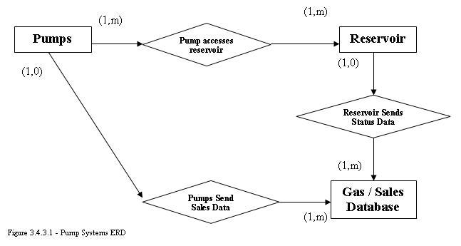

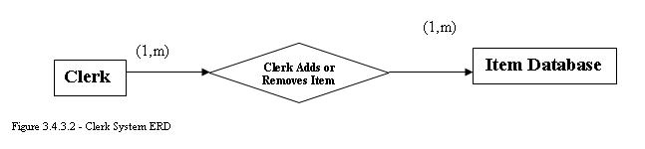

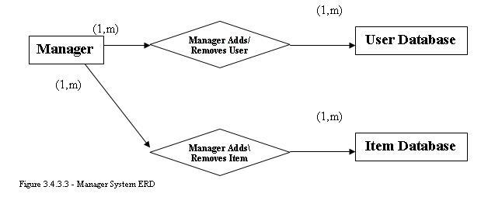

2.4.4. Database Integrity

The integrity of the database should not be compromised by any user operations. The system will handle all modifications to the database independent of user functionality.

The possibility exists of integrity being compromised in the rare scenario of Internet connectivity dropping during a database operation, or an end station malfunctioning during a database operation. GPSP will attempt to resolve erroneous database transactions by canceling the operation. If this does not succeed and database problems occur, please contact Equilibrium Inc. and inquire about the availability of our database analysis software, or ask for support.

2.4.5. Database Retention

The regional office server is required to be fully backed up every night with two duplicate tapes - one to be stored onsite, and one to be stored at a secure offsite location. The server will come equipped with two Sony StorStation AIT130 AIT tape drives, as well as Computer Associates BrightStor Arcserve v9 for Linux backup software.

The hardware and software will be configured for the operation of a redundant GFS rotation including 6 daily tapes, 5 weekly tapes, and 12 monthly tapes. All backup operations will be full.

Staff at the regional office will be instructed on the operation of the tape backup system in order to monitor success/failure of the job, as well as to switch tapes daily. Staff will be instructed to contact Equilibrium Inc. if any problems arise preventing the success of database retention.

2.5. Design Constraints

2.5.1. Standards Compliance

All documentation for GPSP will be created in Microsoft Word version 10 in accordance with the style sheet of Equilibrium Inc.

Interfaces on the end systems shall comply with the standards of web browser software, including functionality to navigate backwards/forwards throughout the interfaces, and graphical interface items native to web browser software.

2.5.2. Environmental Requirements

2.5.2.1. Hardware Environment Requirements

The minimum specifications for GPSP to run on end stations are detailed below:
- Pentium IV/AMD Athlon CPU
- 256mb RAM
- 10gb hard drive
- Functional keyboard (store machines only)
- Functional mouse
- 100mbps Ethernet card
- SVGA display capable of 1024x768x16 resolution/color

The minimum specifications for GPSP to run on the regional server are detailed below:
- Pentium IV/AMD Athlon CPU
- 512mb RAM required, 1024mb recommended
- RAID5 hard drive array using either SCSI or SATA hard
- Disks to provide a total of 120gb disk space
- Functional keyboard
- Functional mouse
- SVGA display capable of 1024x768x16
- 100mbps Ethernet card
- 2 AIT tape drives

2.5.2.2. Software Environment Requirements

Any operating system that allows the use of a graphical web browser can be used on the end stations. We recommend the use of Windows 2000 or Windows XP. We also recommend keeping up-to-date on any software or security updates available for the operating system.

The regional office server requires the use of the FreeBSD operating system, version 5.2 or newer. The server requires proper installation and configuration of the Apache web server version 1.3.29 or newer, of MySQL version 3.23.56 or newer, and of BrightStor Arcserve for Linux version 9 or newer. Staff shall not be responsible for installing, configuring, maintaining, and upgrading the software on the regional office server. Software support will be the responsibility of Equilibrium Inc.

2.6. Software System Attributes

2.6.1. Reliability

The GPSP system natively supports robust reliability. Failure rate is 0.001% on database transactions provided the requirements throughout documentation is met. The GPSP system will attempt to handle data transaction failure by canceling the transaction. Success rate on a proper transaction cancellation are 95%. See 3.4.4 for more information on database integrity concerns.

2.6.2. Availability

The procurement of equipment fulfilling all of the documented necessary hardware and software requirements will be simple given the accessible nature of the requirements. Replacing any component of the GPSP system is not recommended without first contacting Equilibrium Inc., but this is not a strict requirement. Equilibrium Inc. can obtain any replacement equipment needed if desired. Contact Equilibrium Inc. for more information.

2.6.3. Security

The security of GPSP is handled with a few simple operations. Each user will have a user id and password that controls accessible information and functionality. All passwords will be encrypted. Any communication to the regional office server for database operations will be encrypted by 56-bit SSL protection. Any message communication between the end systems and the regional office will be login-specific.
It is recommended that users practice common password-keeping policies, that the operating system on the end stations is updated regularly, and that any equipment providing Internet access to the network is secured by common policies, such as making sure all unnecessary ports are closed.

2.6.4. Maintainability

The core functionality of GPSP will be developed using the PHP scripting language (v4.1) along with HTML. Because of the standard nature of these two languages, the software will be easy to maintain for the case of any bug/problem fixes necessary, or desired changes in functionality.

2.6.5. Portability

The design and development of the interfaces on the end systems will offer high portability between operating systems due to the standard nature of PHP and HTML. The code for database operations with the MySQL software is not natively as portable, but nonetheless remains portable should problems or concerns result in the usage of the established hardware and software requirements.

2.7. Supporting Information

2.7.1. State Transition Diagrams

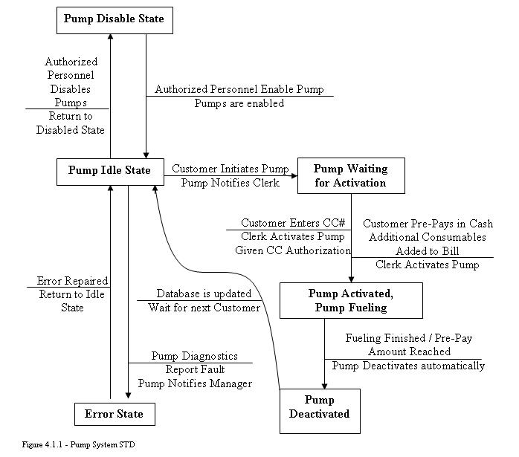

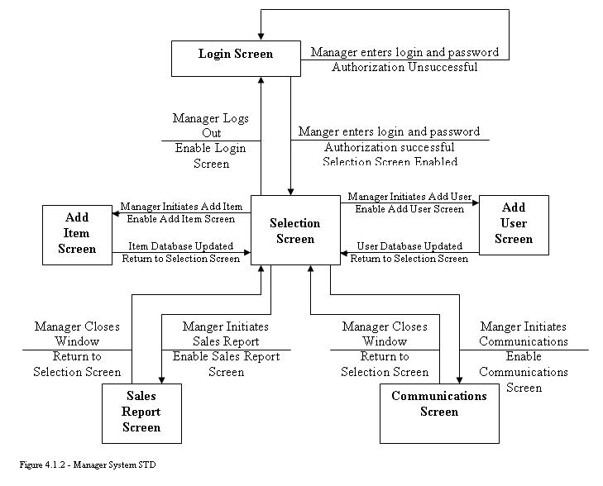
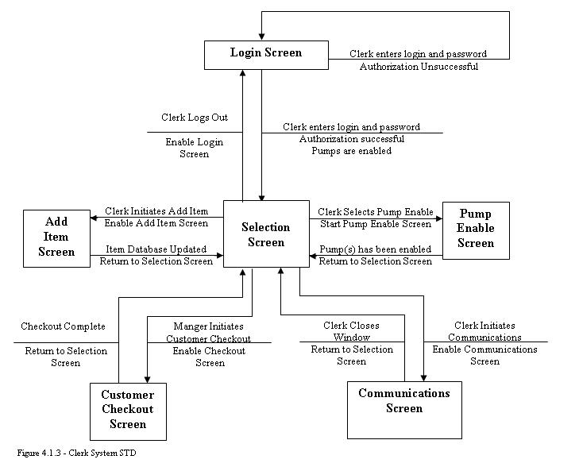

2.7.2. Data Flow Diagrams

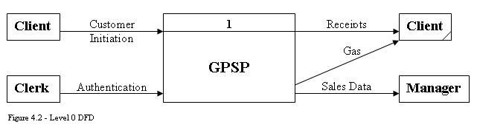

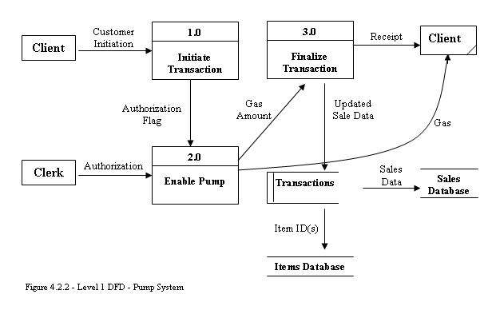
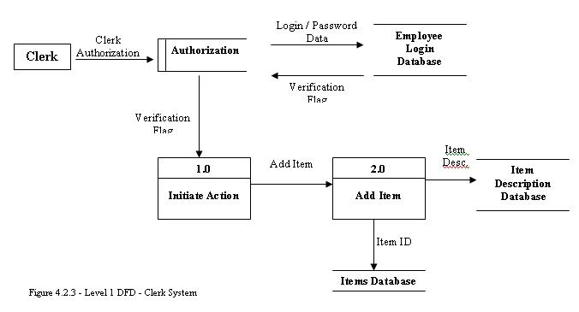

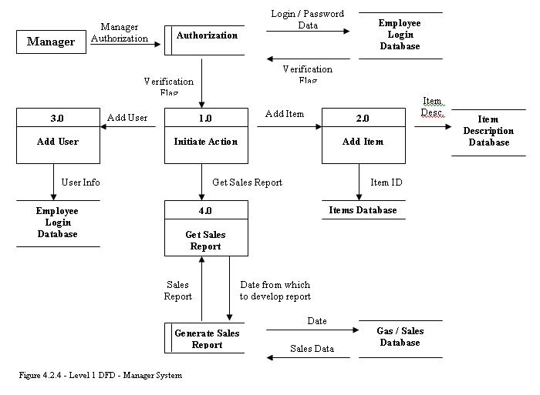

2.8. Specific Requirements Document Index

2
2.1.5. External Interface Requirements 16
2.1.5.2. Hardware Interfaces 16
2.2.3. Manager 22

C
Clerk 15
Client 15

D
Data Entities and Relationships 25
Data Flow Diagrams 32
Database 15
Database Integrity 26
Database Requirements 25
Definitions 15
Design Constraints 27
Distribution Center 15

E
Employee 16
External Interface Requirements 16

F
Functional Requirements 17

G
Gasoline station 15
GPSP Application 16

M
Maintainability 29
Manager 16

P
Performance Requirements 24
Portability 29
Purpose 15

R
References 16
Report Generator 16

S
Scope 15
Security 28
Software Environment Requirements 28
Software System Attributes 28
State Transition Diagram 29
Supporting Information 29

U
Usage and Accessibility 25
User 16

